GALLATIN FIELD AIRPORT - NON-MOVEMENT AREA DRIVING GUIDE

AIR OPERATIONS AREA (AOA) ID BADGE’S MUST BE IN YOUR POSSESSION AT ALL TIMES WHILE YOU ARE IN THE AOA UNESCORTED AND AVAILABLE FOR INSPECTION.
This guide is intended for persons who must drive vehicles or motorized equipment on the Non-Movement Areas of Gallatin Field. Driving on the general aviation ramp, old terminal ramp, and east ramp is restricted to persons loading, unloading and servicing aircraft located on those ramps. Driving in these areas must be limited as much as possible. You must proceed via the shortest paved route to your destination and exit the area via the same route. Sightseeing and un-necessary driving in these areas may result in revocation of your non-movement area driving privileges.
Driving on the Non-Movement Areas in the General Aviation Secure Area
Non-movement areas include taxiways, aprons, and other areas not under control of the ATCT. Anyone authorized to operate a motorized vehicle in the non-movement areas may do so without being in positive radio contact with the air traffic control tower. These areas include;
- Service roads
- Cargo aprons
- General aviation aprons
- General aviation taxiways in the south hangar and east ramp areas
You are not authorized to drive on the air carrier apron or air movement areas.
Driving. Operating within the ramp and hangar taxiway areas requires the vehicle driver to exercise extreme caution as aircraft are always moving, aircraft passengers may be walking from the aircraft to a building, and noise levels are high.
Vehicle drivers should—
- Never drive between safety cones or across delineated passenger walkways.
- Watch cockpit blind spots—pilots typically cannot see behind or below the aircraft.
- Avoid jet blast or prop wash, which can blow debris or overturn vehicles.
- Be aware and avoid moving propellers that can cause damage, injury, or death.
- Be aware of other vehicle movements—you may not hear them approaching due to aircraft engine noise.
- Yield to aircraft, passengers, and emergency vehicles, which ALWAYS have the right-of-way on any portion of the airport.
Non-Movement Area Boundary Markings consist of two yellow lines (one solid and one dashed). The solid line is located on the non-movement area side, while the dashed yellow line is located on the air movement area side. You are not authorized to drive in the air movement area.
Non-Movement Area Boundary Marking
Air Movement Area (Controlled by the ATCT)
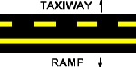
Non-Movement Area
Escorting. Any person or vehicle under escort must remain under escort until they have left the Air Operations Area.
General Aviation Access Gate Zones
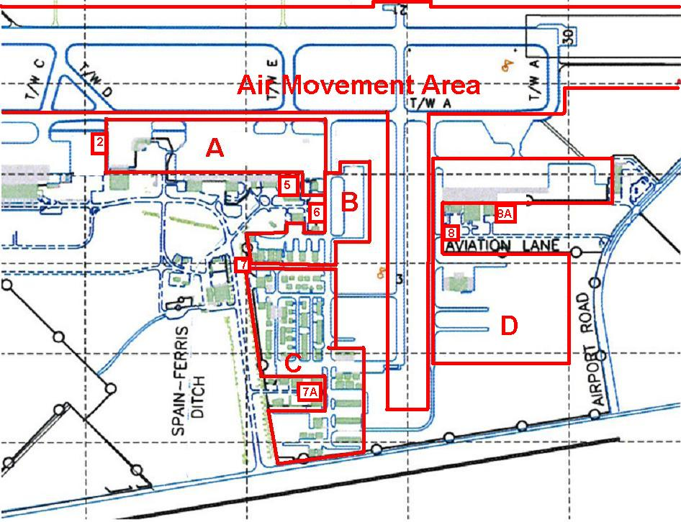

Federal Regulations under 1540.105 require the following Security Responsibilities of each individual granted un-escorted access to the Air Operations Area:
- NO PERSON MAY:
Tamper or interfere with, compromise, modify, attempt to circumvent, or cause a person to tamper or interfere with, compromise, modify or attempt to circumvent any security system, measure or procedure implemented.

Enter, or be present within the Air Operations Area without complying with the systems, measures, or procedures being applied to control access to, or presence or movement in, such areas.

Use, allow to be used, or cause to be used, any airport issued or airport-approved access medium that authorizes the access, presence, or movement of persons or vehicles in the Air Operations Area in any other manner than that for which it was issued by the appropriate authority.

